FP IA Feedback (on modeling).

Please study all the excerpts below and identify good points and areas for improvement.

Excerpt 1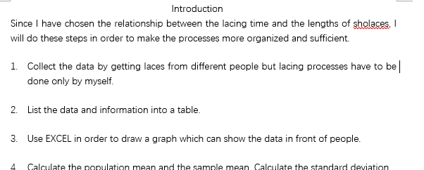

1. Please comment on its aim, introduction and rationale.

Aim: it is not clearly stated

The introduction is not clear and that is not the correct form of an introduction

Clear but not enough

Cannot in bullet points

There is no rationale

Coherence, not linked.

Excerpt 2.

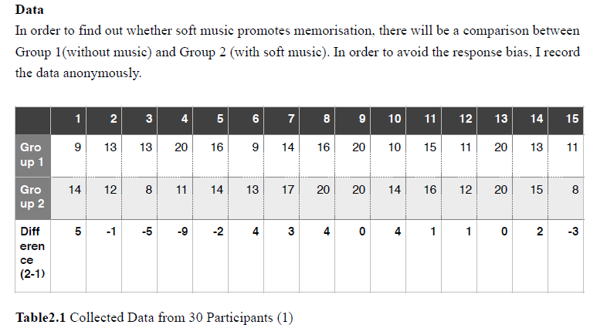

<the student then produced the following representation in the next page.>

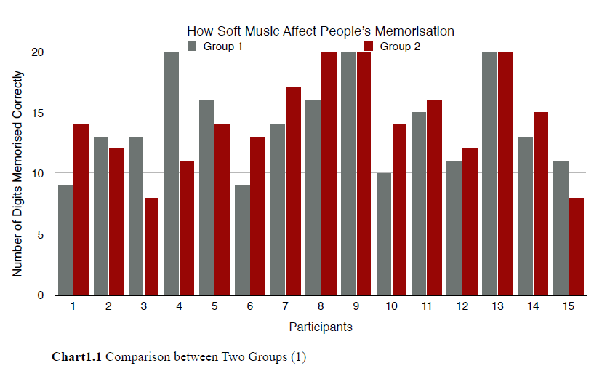

2. Comment on the mathematical presentation. What should be the focus here?

Notation

Term

…

Not appropriate, the table is not fully explained: what does each data stand for

The chart is better to have the difference demonstrated.

It looks messy.

Excerpt 3.   
 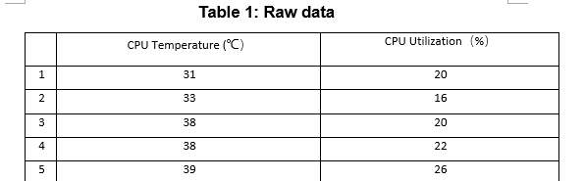  
<Part of the entire table is shown here. At the end of the table, the student has the following.>   
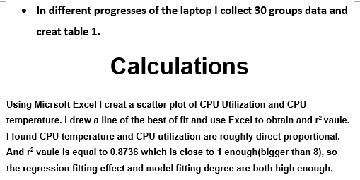

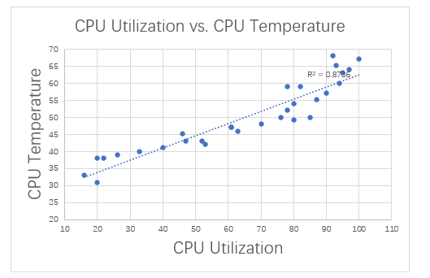

3.Comment on the coherence, mathematical presentation and mathematical process.

Not so good in coherence, as when it says calculation, there is actually no calculation but only analysis. Sometimes we cannot understand phrases like “8” “fitting”

The mathematical presentation is good and useful, there are clear explanation for what each set of data is for. Still, it will be better if the graph has the formula for the line of best fit.

Mathematical process

If linear:

* How much these variables are related linearly.

“r” coefficient of correlation

Reflect: does my r make sense

* Reflect: how good is the fit? R^2

Is this a good model

Are there other models

Make/explore other models

Compare models: which is the best

* Use it for what?

What’s the domain?

Is it realistic?

What’s the assumption?

Excerpt 4. This is a continuation of the same work as in excerpt 3.

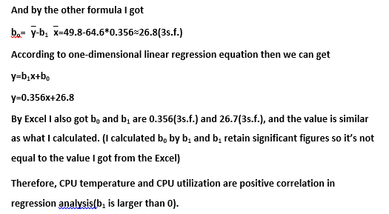

<The student did not build any other model.>

4. Comment on the mathematical presentation, analysis, result, and reflection.

Excerpt 5.   
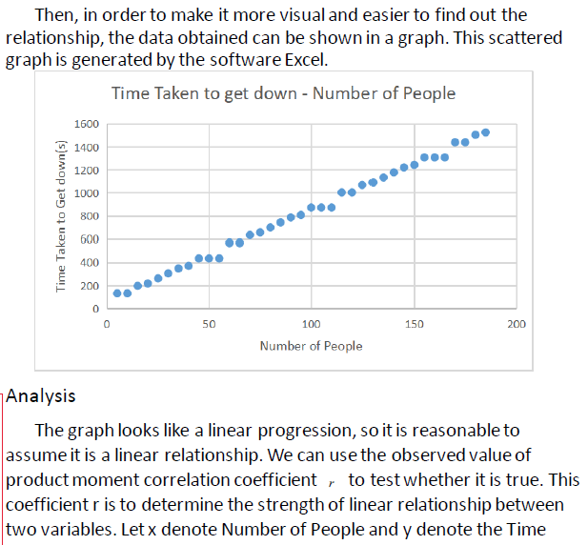

5. You may want to contrast this with the presentation in excerpt 3 and comment on which is more logical in presentation.   
6. The student explored linear regression and attempted quadratic and exponential models as well. Comment on the choice of model here.

Graph🡪explain the pattern

Step function instead of linear.